* Overview of Project

To visualize the database by using Excel skills

* Analysis and Challenges

There is no big challenge I encountered in this module, yet it is a fresh start to learn Excel. I have been learning Excel since junior high school, but more focused on organizing and learning very simple, basic skills to understand the worksheet.

This is my first time learning how to use Excel debugging, analyzing, and solving the problem.

The new tool I learned during this module is PivotTable, which helps to choose the data we want and analyze the data and filter the data to create the Pivot Charts.

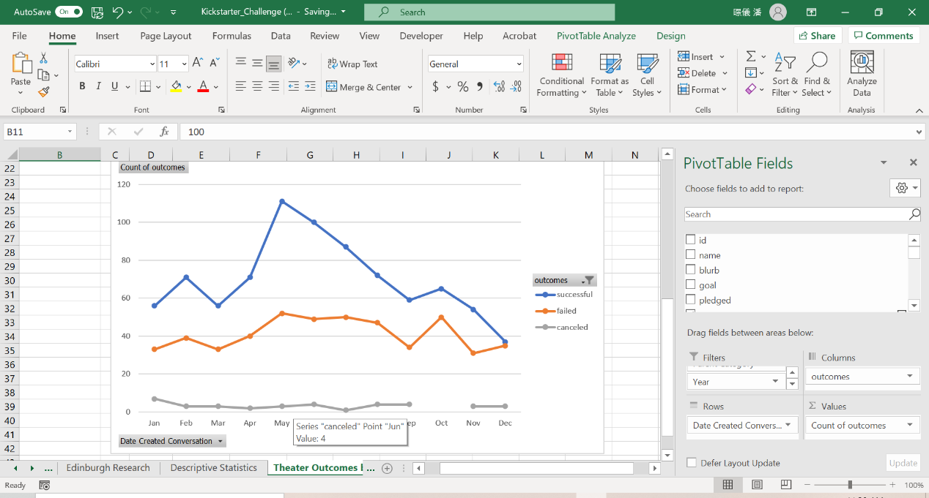

Also, the VLOOKUP, I’ve heard the tool is helpful to find specific cells or columns in worksheets. Although it took me some time to figure out how does the formula works, once I understood it, it is a lot useful than using the “Find and Place” tool.

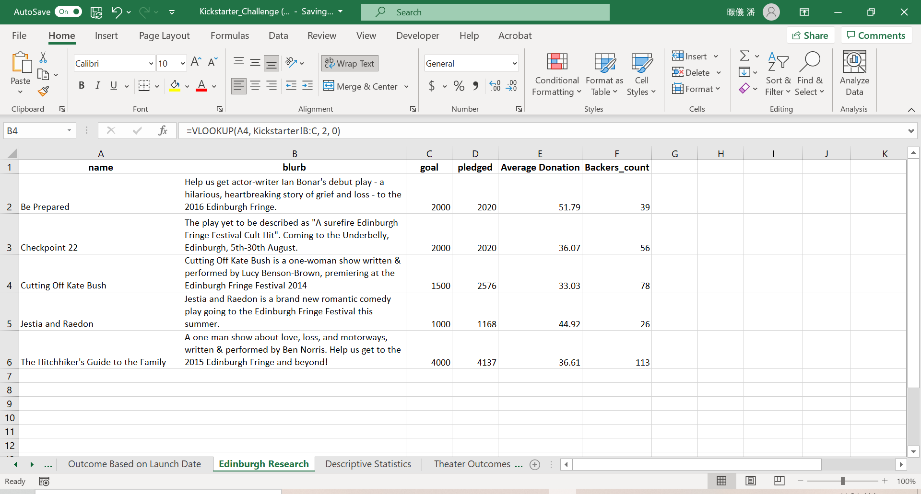

* Results

1. What are two conclusions you can draw about the Theater Outcomes by Launch Date?
2. May and June are the most successful months.
3. There is no cancel campaign in October
4. What can you conclude about the Outcomes based on Goals?

Based on the dataset, the amount is from $1,000 to $9,999. The lines of the percentage of successful and failed are the symmetrical plot.

1. What are some limitations of this dataset?

It can’t tell the dataset is using “plays” as the criteria to analyze the data.

1. What are some other possible tables and/or graphs that could create?

I think it could create by Pivot tables or still using line or bar charts but need to provide more criteria of the data.